# tt

# Basically, the index page structure should be as below:

# 

# Index Page: Landing Page for traner and learner → get started



# Service details for each offering

Req: How it works for each service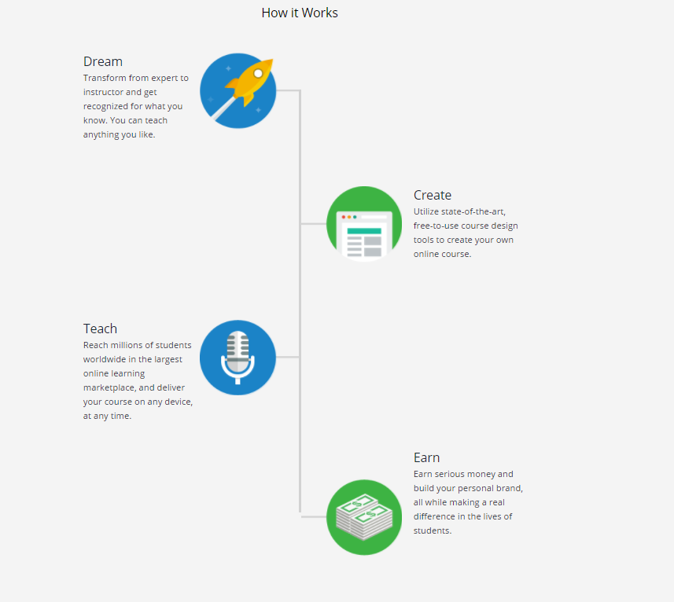

Catalog Serach results

<https://demo.academyofmine.com/course/>

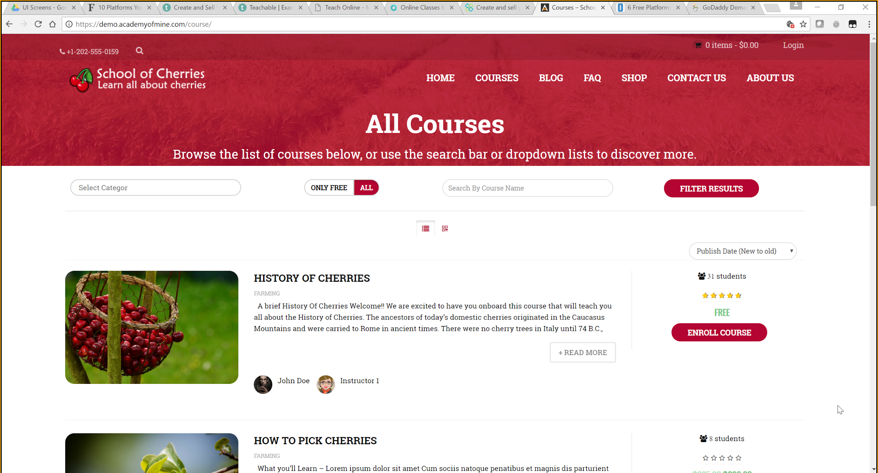

**Match Making UI Flow:**

**Learner** :

see the pic attached (Learner_Match Making)

**Trainer:**

Trainer Profile:

Learner Profile:

Job Oriented

Trainings

On Job Support

Project Experience

Are you an Expert Trainer?

Get started >

How it works?

Looking for a career start?

Get started >